SERIES and PARALLEL Resonance
Series resonance and parallel resonance are two phenomena that occur in electrical circuits containing inductors, capacitors, and resistors. They represent different ways in which circuits respond to an alternating current (AC) signal at a specific frequency.
Thus as frequency changes the impedance become min or max, called as resonance.

Series Resonance -Series resonance is a phenomenon that occurs in electrical circuits containing a resistor (R), inductor (L), and capacitor (C) connected in a series. It occurs when the inductive reactance (XL) and capacitive reactance (XC) cancel each other at a specific frequency, resulting in a minimum impedance and maximum current flow through the circuit.
At resonant frequency, the inductive and capacitive reactance are equal and opposite, resulting in resonance. The resonant frequency (f) can be calculated using the formula-


where,
f = resonant frequency (Hz)
L = inductance (H)
C = capacitance (F)

In series resonance circuit, the current is max and the impedance is min.

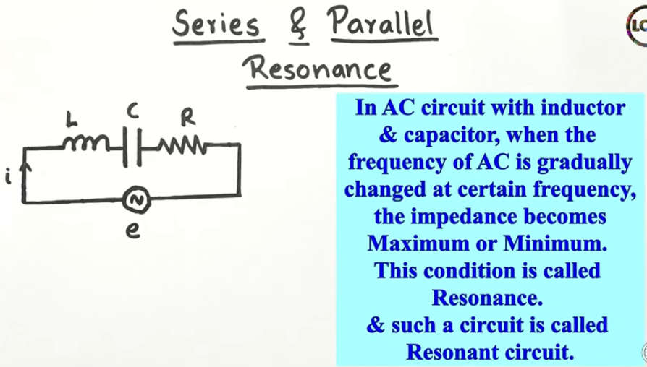
Impedance calculations-
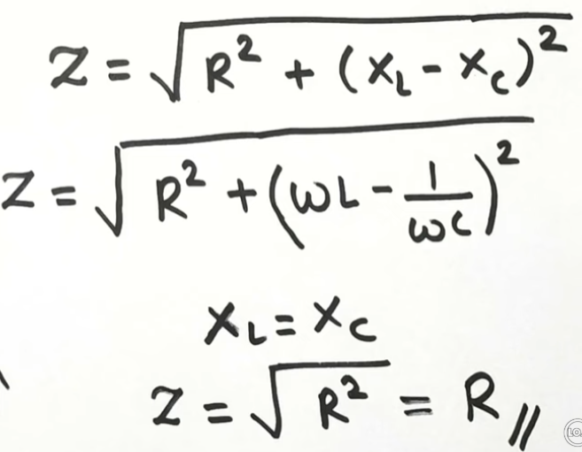
At resonance, the total impedance (Z) of this circuit equals to the resistance (R), resulting in minimum impedance.
At resonance-
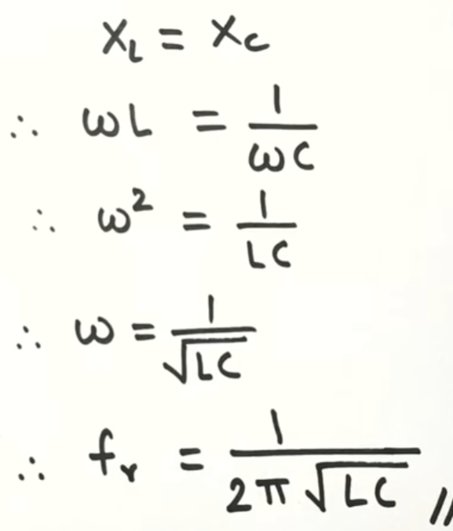 is the frequency of resonance.
Graph
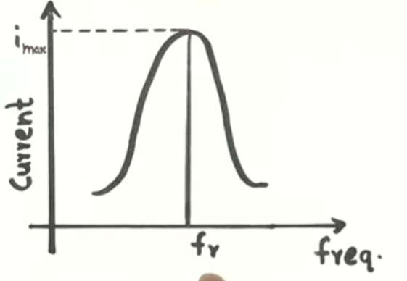

Applications of Series Resonance

Series resonance has various applications in electronics and elecommunications, including in tuning circuits, filtering, and impedance matching. It is utilized in devices such as radio receivers, oscillators, and filters to select specific frequencies or reject unwanted ones. Some common applications of series resonance are:

- Oscillator circuits
- Voltage amplifiers
- High frequency filters, etc.

( If more mks or detail)
- Tuning circuits in radios and televisions to select specific frequencies.
- Bandwidth control in bandpass filters for communication systems.
- Power factor correction in electrical power distribution systems to improve efficiency.
- Voltage regulation in voltage stabilization circuits.
- Frequency stabilization in oscillators and frequency synthesisers.

Parallel Resonance - When a resistor (R), inductor (L), and capacitor (C) are connected in parallel and the effect of the inductor cancels the effect of the capacitor at a specific supply frequency, it is called parallel resonance. The resonant frequency (f) can be calculated using the formula-


where,
f = resonant frequency (Hz)
L = inductance (H)
C = capacitance (F)

At resonance, the circuit experiences maximum impedance, resulting in minimum current flow. Parallel resonance makes the circuit behave like a pure resistive circuit, and is utilized in various applications.

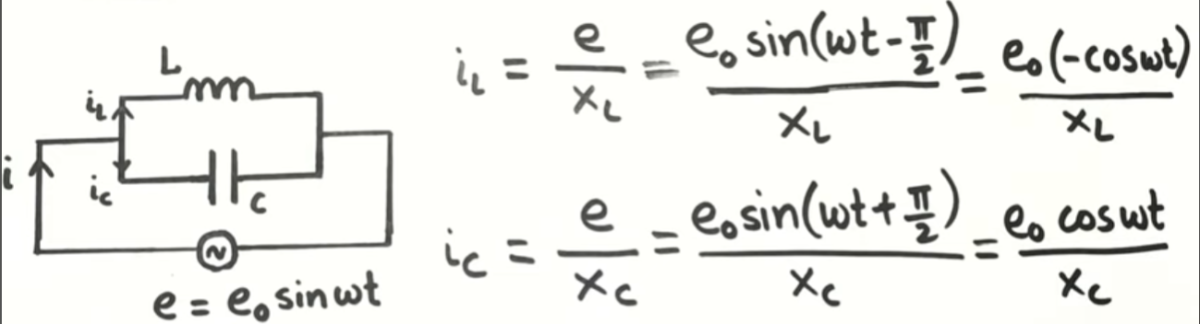

In series resonance circuit, the current is min and the impedance is max.

Total current i

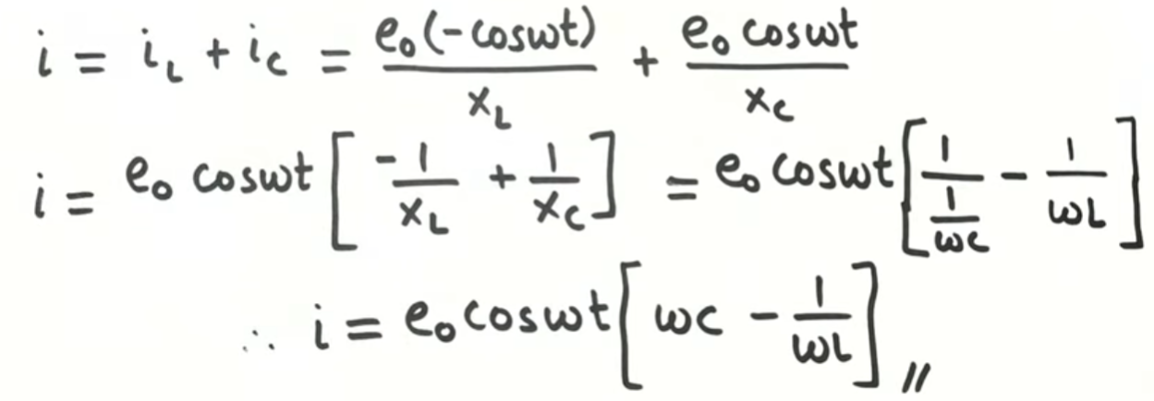
At various input frequencies, the circuit will resonant at a frequency when current is min, XL=XC called resonant frequency
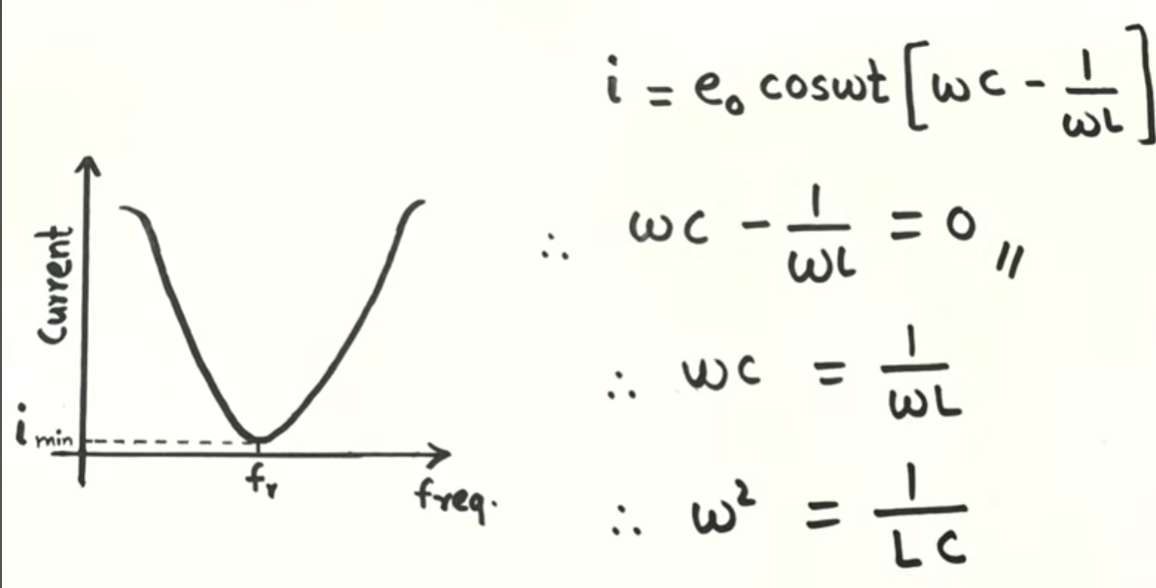
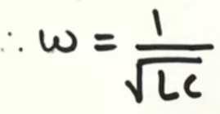
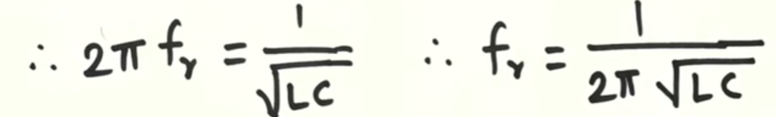

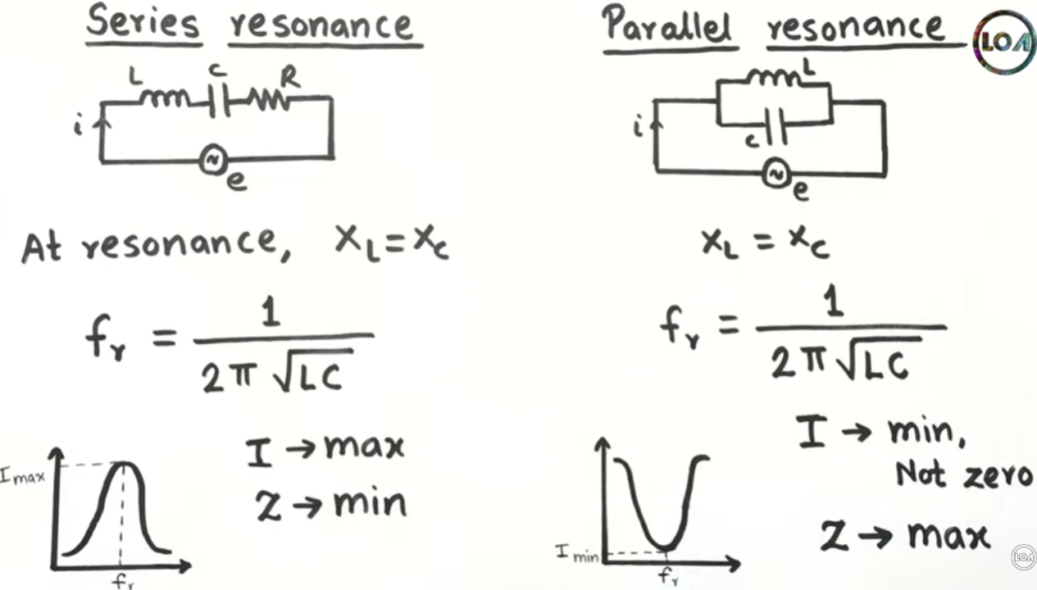

Applications of Parallel Resonance
Parallel resonance has various applications in electronics and telecommunications, including in tuning circuits, filtering, and impedance matching. It is utilized in devices such as band-pass filters, antenna circuits, and impedance matching networks. Some common applications of parallel resonance are:
- Current amplifiers
- Filter circuits
- Radio frequency amplifiers
- Induction heating systems, etc.

(If for more mks or detail)
- Filter circuits for removing specific frequencies in communication systems and audio equipment.
- Voltage regulation in power supplies to stabilize output voltage levels.
- Antenna tuning in radio frequency (RF) circuits for maximizing signal reception.
- Tank circuits in oscillators for generating stable oscillations at a specific frequency.
- Impedance matching in RF amplifiers and antennas to maximize power transfer.

(Series resonance occurs when the inductive and capacitive effects cancel each other out in a series circuit, resulting in maximum current flow. Parallel resonance, on the other hand, happens when the same effects cancel out in a parallel circuit, leading to minimum current flow.)

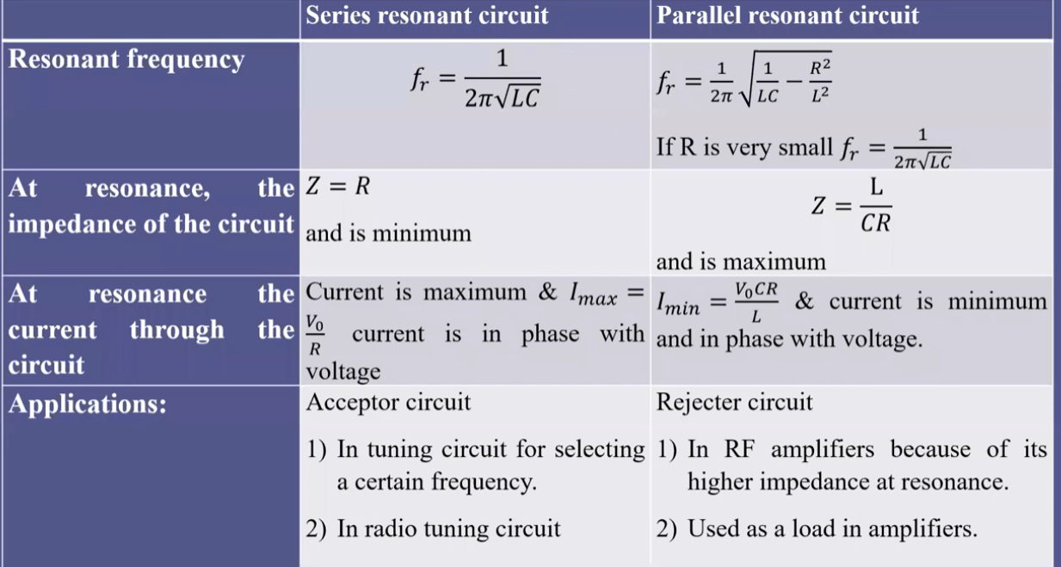
5. Add graph

